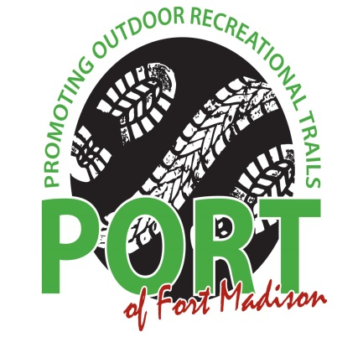KIDS’ RACE 5K RUN/WALK 10-MILE BIKE DUATHLON
6th Annual
“spooktackular boo-athlon”

FUNDRAISING EVENT TO CREATE AND CONNECT TRAILS IN OUR COMMUNITY.
PARTICIPANTS ARE ENCOURAGED TO WEAR HALLOWEEN COSTUMES

OCTOBER 26, 2019 – 9:00 AM
BAXTER SPORTS COMPLEX, 909 48TH ST., FORT MADISON, IOWA

Early Registration Mail forms by October 11, 2019

Awards 5K Run/Walk, Bike Only, Duathlon, and medals to all kids under 12.

Age Groups Under 12, 12-15, 16-19, 20-29, 30-39, 40-49, 50-59, 60+

October 25, 2019 5:00 PM-7:00 PM Early pickup/Registration – Baxter Sports Complex
October 26, 2019 7:00 AM Packet pickup/Registration – Baxter Sports Complex
9:00 AM Kids Race
PORT Water Bottles 9:15 AM 5K Run/Walk, Bike only, Duathlon
Available for Purchase! 10:30 AM Awards & Prizes for Best Costume

Make checks payable to: City of Fort Madison-PORT
Mail to: Attn: Community Relations, Fort Madison Community Hospital, P.O. Box 174, Fort Madison, Iowa 52627

Name: ____________________________________________________________Email:_________________________

Street, City, State, _________________________________________________Phone:_________________________

Sex: M F Age on Race Day: ______ Long Sleeve Shirt Size: Youth: XS S M L XL

Water Bottle-Advance sales: $5:00 __________ Long Sleeve Shirt Size: Adult: S M L XL 2XL

Bike Jerseys - $75.00 (run small) Women’s: XS S M L XL 2XL Men’s: S M L XL 2XL 3XL

(Circle one) Kid’s Race 5K Run/Walk Bike Only Duathlon (run/bike/run)

Kid’s Race: $10 Early Registration w/Shirt $10 after Oct. 11th or day of race – Shirt not guaranteed
5K Run/Walk $20 Early Registration w/Shirt $25 after Oct. 11th or day of race – Shirt not guaranteed
Bike Only $20 Early Registration w/Shirt $25 after Oct. 11th or day of race – Shirt not guaranteed
Duathlon: $35 Early Registration w/Shirt $40 after Oct. 11th or day of race – Shirt not guaranteed

Waiver: By submitting this entry form, I hereby, for myself, my heirs and my executors, waive and release all rights and claims
for damages I may have against PORT, City of Fort Madison, all sponsors, race directors, and management’s organizations for any injuries suffered by me in this event. I attest that I have trained sufficiently to participate in this event and I am physically fit.

________________________________________________ _______ ____________________________ ______________
Participant’s Signature /Participant’s name if under 18 Parent’s Signature if under 18 Date

